|  |
| --- |
| AA Games |
| GAME2014-F2021-Assignment2-Part2 |
| **Jinxx** |
| Version #XX  All work Copyright © 2021 by XX Games.  All rights reserved. |
| **[Amer Ali Mohammed]** |
|  |



|  |
| --- |
| December 12th 2021 |

**Table of Contents**

[Your Table of Contents should go here. Make sure that your document’s sections are hyperlinked to their corresponding pages.]

|  |  |  |
| --- | --- | --- |
| **SL NO** | **Content** | **PG.NO** |
| 1. | Version History | 3 |
| 2. | Game Overview | 4 |
| 3. | Game Play Mechanics | 4 |
| 4. | Camera | 4 |
| 5. | Controls | 5 |
| 6. | Saving and loading | 5 |
| 7. | Interface Sketch | 5 |
| 8. | Menu & Screen Descriptions | 6 |
| 9. | Game World | 10 |
| 10. | Levels | 10 |
| 11. | Game Progression | 10 |
| 12. | Characters | 11 |
| 13. | Non-Player Characters | 11 |
| 14. | Enemies | 11 |
| 15. | Weapons | 11 |
| 16. | Items | 11 |
| 17. | Abilities | 11 |
| 18. | Vehicles | 11 |
| 19. | Script | 12 |
| 20. | Scoring | 12 |
| 21. | Sound Index | 12 |
| 22. | Art/Multimedia Index | 12 |
| 23. | Future Features | 13 |

**Version History**

[This is where you keep track of the detailed changes made to your document throughout the course of development.]

|  |  |  |
| --- | --- | --- |
| SL.No | Date : | Description |
| 1. | Nov 22, 2021 | Added initial files & Project Settings |
| 2. | Nov 23, 2021 | Added some level design |
| 3. | Nov 24, 2021 | Added more level design and internal documentation to the code. |
| 4. | Nov 25, 2021 | Added test background player, enemies and platforms. |
| 5. | Nov 26, 2021 | * Added basic Score System. * Added remaining Lives HUD and health system for player * Added Flying Eagle enemy and shoot ability for it. |
| 6. | Nov 27, 2021 | Added basic Main Menu with Start And Quit. |
| 7. | Nov 28, 2021 | * Added Audio Manager and explosions to the enemy bullets * Added Basic Instruction screen |
| 8. | Nov 29, 2021 | * Added proper flip to the eagle upon player respawn * Fixed some bugs to have the apk build run properly * Added Death Screen fixed platform movement and added pickups |
| 9. | Nov 30, 2021 | Added Pause Screen. |
| 10. | Dec 1, 2021 | Updated Score UI and added score on death screen. |
| 11. | Dec 3, 2021 | Updated Instructions screen and finished the level design, added extra enemies and polished some UI. |
| 12. | Dec 11, 2021 | Added init files from assignment 1 and changed the level1 music |
| 13. | Dec 12, 2021 | Updated project settings and added random colored pickups.  Added random Colored pickups and more UI button audio.  Added Checkpoint System and fixed issues with bullet collision, Added more platforms.  Fixed some audio and UI issues. |
| 14. | Dec 13, 2021 | Added GDD and Apk build. |

[This is the body of your video game design document. You should add and delete sections as they pertain to your game’s design.]

1. **Game Overview**

*(ensure you mention the goal of the game and how to win if applicable)*

*Jinxx is a mobile landscape perspective 2D platformer game in which the player is required to collect all the stars scattered through the level avoiding enemies and enemy bullets and preserving atleast one life until all the coins are collected. Player falling of a platform result in respawning of the player at the start of the level & colliding with enemies or enemy bullets will deduct a life off the player’s remaining lives.*

1. **Game Play Mechanics**

*(how does your game work?)*

*Using Movement and Jump mechanics player needs to avoid hitting enemy bullets and enemies to preserve their health and avoid falling off platforms as respawn is at the previous checkpoint of the level.*

1. **Camera**

*(Point of View)*

*2D Locked-On Camera platformer.*

1. **Controls**

*(Which keys does your game use? Does it use the mouse or a joystick?)*

*On Screen UI controls(Android)*

*WASD – Movement, Space – Jump (PC)*

1. **Saving and Loading**

*(Does your game include saving and loading? When? How?)*

*Game uses prefabs to save and load the collected stars as score from the main screen onto the eath screen/Win.*

1. **Interface Sketch**

*(What does the game interface look like? Provide a screen shot or sketch)* 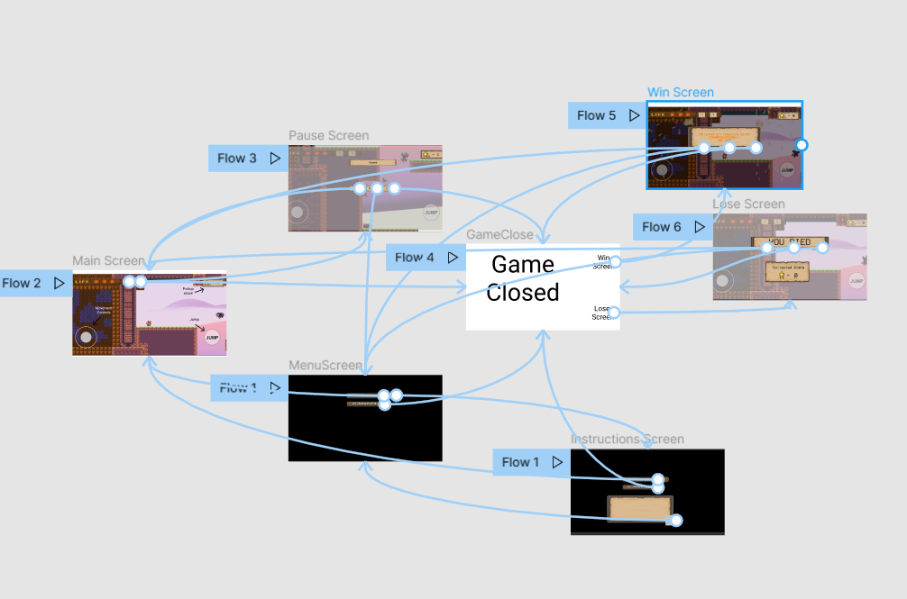

**Mockup of the game’s UI wireframes in Figma –**

<https://www.figma.com/proto/2smw2HbY1NWBJ642Feomd2/Untitled?node-id=2%3A2&scaling=scale-down&page-id=0%3A1&starting-point-node-id=10%3A3&show-proto-sidebar=1>

1. **Menu and Screen Descriptions**

*(Include additional screen shots and accompanying descriptions for any menus and additional screen)*

*Used Sunnyland assets for most of thegame and created own buttons for UI*

**Menu Screen**

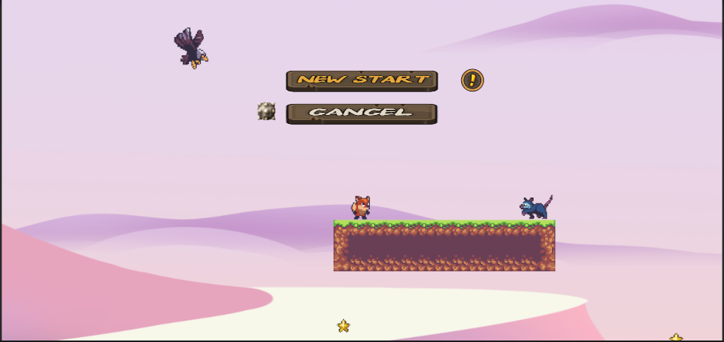

**Instructions Screen**

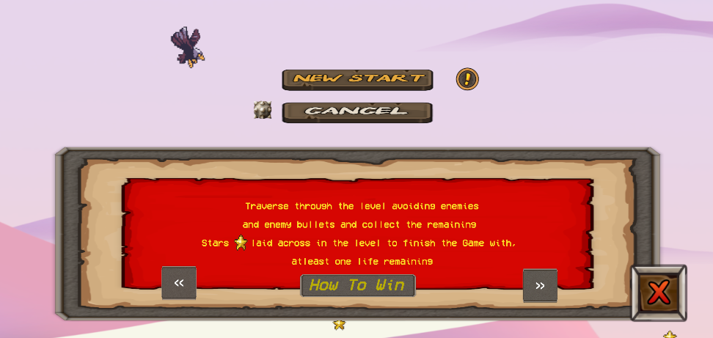

**GamePlay/Level Screen**

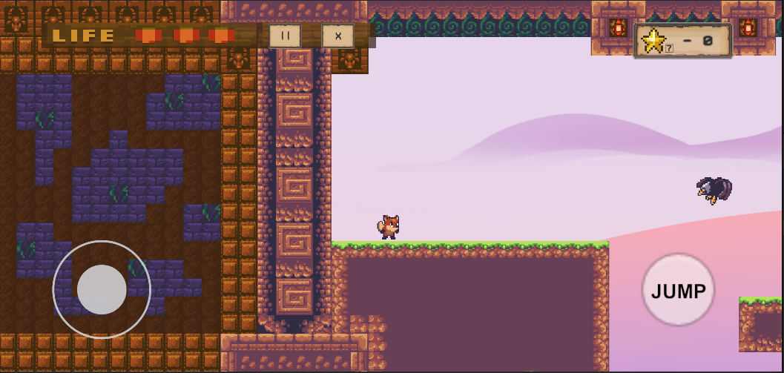

**Death Screen**

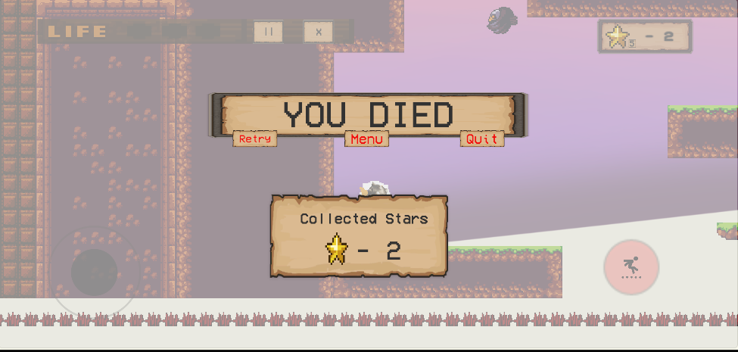

**Win Screen**

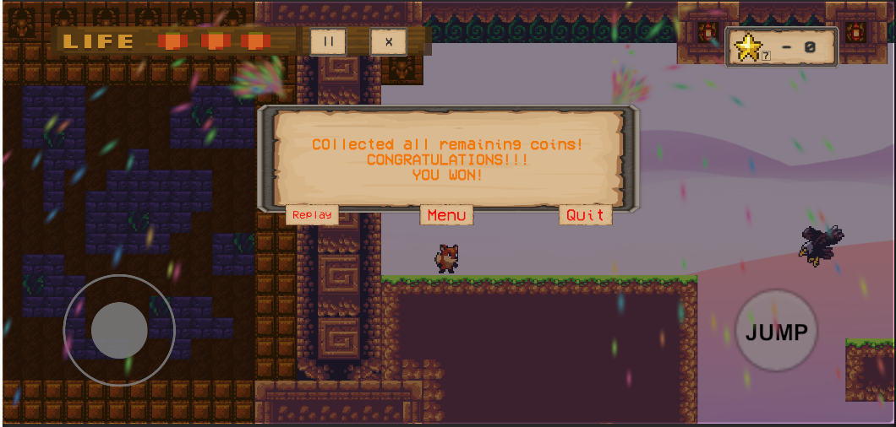

**Pause Screen**

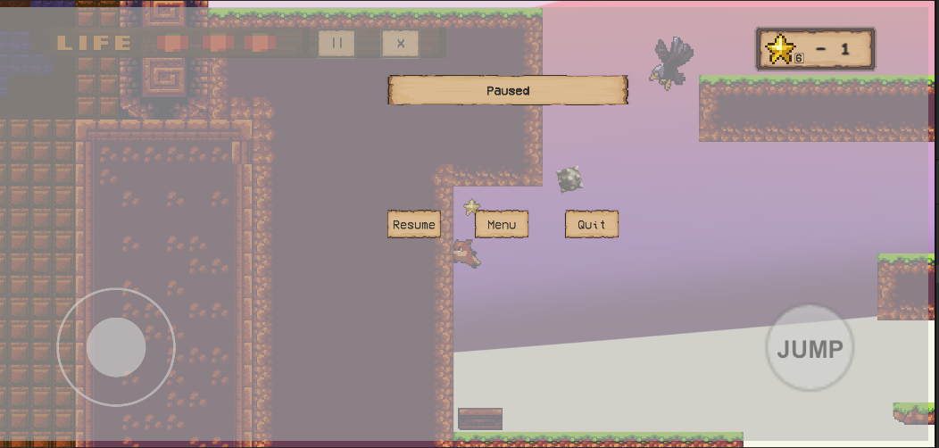

**Platforms**

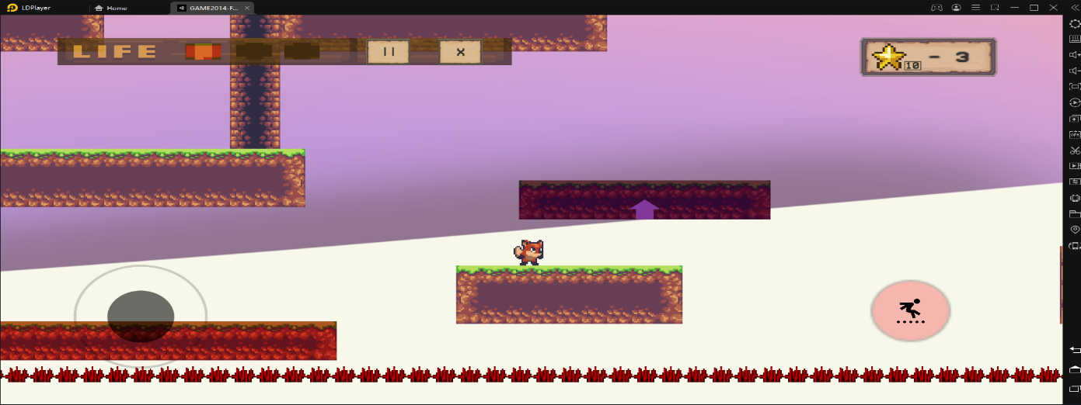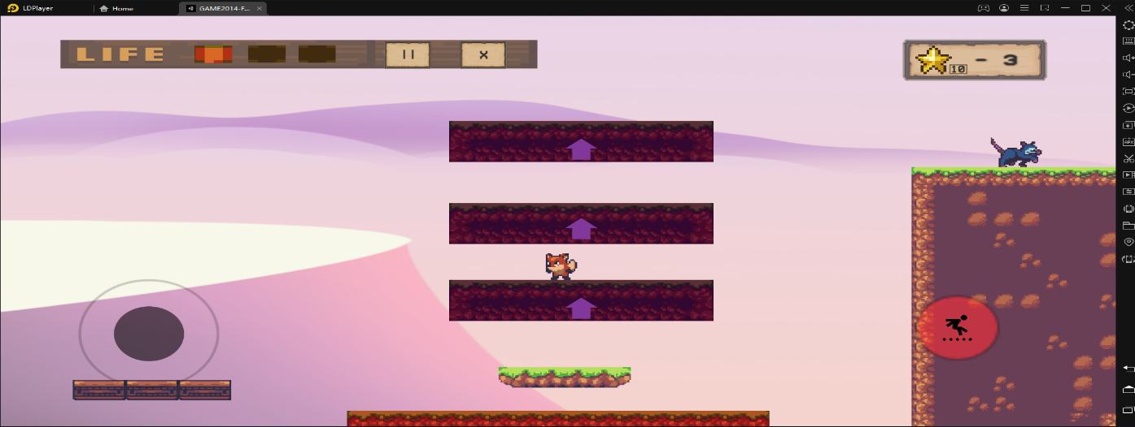

**Coins**

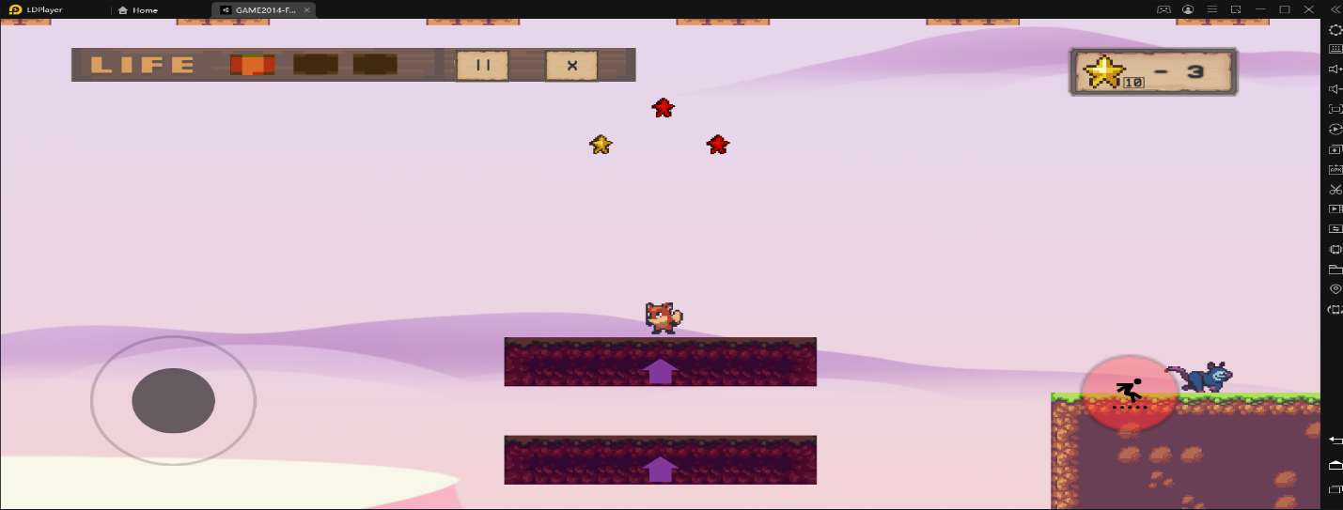

1. **Game World**

*(Describe Your Game Environment)*

*The Game is locked in landscape resolution and have the controls and HUD at the bottom of the screen. The game has platforms, moving platforms, bouncing platforms, eagle enemy with bullets, possum enemy no bullets, pickup stars & Player.*

1. **Levels**

*(Describe Each of your game levels)*

*Level includes :*

*Player, flying in vertical motion & bombs shooting capable Bird enemy which can change direction upon player collision with its collider, flying in Horizontal motion & bombs shooting capable Bird enemy which cannot change directions, Possum enemy with Line of sight and ground/platform walking capability, Horizontal, Vertical & Diagonal Up moving platforms, Bouncing platforms, Death panel at the bottom of the level.*

1. **Game Progression**

*Collecting all the remaining Stars laid across the level.*

1. **Characters**

*(Describe Your game avatar if applicable)*

*Player fox character, Flying Bird enemies * 2, walking/patrolling possum enemy.*

1. **Non-player Characters**

(Describe Any Computer controlled Allies and how they work)

Floating and animating star power-ups, Brick blocks.

1. **Enemies**

*(Describe computer-generated enemies and boss monsters)*

*Flying in vertical motion & bombs shooting capable Bird enemy which can change direction upon player collision with its collider, flying in Horizontal motion & bombs shooting capable Bird enemy which cannot change directions, Possum enemy with Line of sight and ground/platform walking capability*

1. **Weapons**

*(Describe any weapons available to the user)*

*Birds have bombs shooting capability.*

1. **Items**

*(Describe any in-game items that can help or hinder the user)*

*Random colored Star pickups,Two-way, moving, sliding and bouncing platforms.*

1. **Abilities**

*Movement, Jump.*

1. **Vehicles**

*Moving Platforms for short distances.*

1. **Script**

*Game Controller, Player Behaviour, Player Animation State, Play Button, Cancel Button, Pause, Score Manager, Audio Manager, Enemy Controller (Possum), Eagle Enemy Controller (Eagle), Buller, Health, Instructions Manager, LOS, Moving Platform Controller, Moving Platform Direction, Pickup, UI Controller, Death Plane Controller, Death Panel.*

1. **Scoring**

*Collect all the remaining coins in game, displayed in UI to win the level. If player loses all remaining health before collecting the coins the player loses the level and gets to retry.*

1. **Puzzles/Mini-games**

*None*

1. **Bonuses**

*None*

1. **Cheat Codes**

*None*

1. **Sound Index**

*(Include an index of all your sound clips)*

*Vintage arcade classic background music from open game art.*

*Sound Effects from Unity asset store free assets for casual sounds and explosion : JUMP, Land, Enemy Fire, Player Hit, Pickup, Fire Miss, Enemy Hit, Button Press.*

1. **Story Index**

*(Outline your game story here)*

1. **Art / Multimedia Index**

*(Include an index of all your graphic and video assets here)*

*Sunnyland, Sunnyland Forest, Sunny Land Woods from Unity Asset Store.*

*Unity 2d Standard Assets,Chiptone*

1. **Design Notes**

*(Include additional design notes here)*

1. **Future Features**

*(Include any future features that are planned to be implemented)*

*More levels, story elements, more enemies, killing ability for player, High score System.*